Aim:
To study the evolution of web technologies and implement web analytics to understand user behavior and website performance.
Objective:
The objective of this experiment is to understand how the web has evolved over time and how web analytics tools can be used to track, measure, and analyze website traffic, user behavior , and overall site performance.
Theory
- What is Web Evolution?
Web evolution refers to the gradual development of web technologies from static web pages to intelligent, data-driven, and interactive platforms.
The evolution of the web is broadly classified into three stages:
- Web 1.0 (Read-Only Web)
Web 1.0 represents the earliest stage of the web where users could only view information. Websites were static and did not support user interaction. Content was published by website owners and consumed by users. Example : Early informational websites.
- Web 2.0 (Read-Write Web)
Web 2.0 introduced user interaction and collaboration. Users could create, modify, and share content. This phase led to the growth of social networking sites, blogs, and web applications. Example : Facebook , YouTube , Amazon.
- Web 3.0 (Read-Write-Trust Web)
Web 3.0 focuses on intelligent, semantic, and decentralized web technologies. It enables machines to understand data and provides personalized content. It also emphasizes data security, privacy, and decentralization using technologies like Artificial Intelligence and Blockchain. Example : AI assistants, smart recommendations
- What are Web Analytics?
Web analytics is the process of collecting and analyzing website data to understand user behavior and measure website performance.
Importance:
- It helps understand how users interact with a website
- It measures performance using metrics like traffic and conversion rate
- It improves user experience and website design
- It supports data-driven decisions to improve website effectiveness

Understanding Web Analytics

Collection of Data : This involves gathering raw data about website visitors such as page views, clicks, traffic sources, device type, and user actions using tools like cookies, tracking codes, and log files.

Measurement of Data : Measurement converts collected data into meaningful metrics such as number of users, sessions, bounce rate, page load time, and conversions to evaluate website performance.

Analysis of Data :Analysis interprets measured data to understand user behavior, identify patterns, trends, and problem areas, and determine whether website goals are being achieved.

Reporting of Data :Reporting presents analyzed data in the form of dashboards, charts, and reports to help stakeholders make informed decisions and improve website performance.

Applications of Web Analytics
- Determining Customer Repurchase Likelihood
Web analytics tracks returning visitors, purchase history, and browsing behavior to predict whether a customer is likely to make repeat purchases.

- Personalizing Website Experience
By analyzing user preferences, location, and past interactions, web analytics helps display personalized content, product recommendations, and offers to users.

- Monitoring Customer Spending
Web analytics monitors transaction data, average order value, and purchase frequency to understand customer spending patterns and identify high-value customers.

Objectives of Web Analytics
  - Business Metrics
Web analytics helps track key business metrics such as website traffic, user engagement, conversion rate, and customer retention to measure overall business performance.

  - Marketing Efficiency
It evaluates the effectiveness of marketing campaigns by analyzing traffic sources, click-through rates, and campaign conversions, helping optimize marketing efforts.

  - Revenue Optimization
Web analytics identifies high-performing products, customer segments, and sales funnels to improve conversions, increase average order value, and maximize revenue.

Web Analytics Tools

Traffic Sources

These statistics show where visitors come from, such as search engines, social media, direct visits, referrals, or paid advertisements. They help evaluate marketing channel performance.

Visitor Engagement

Visitor engagement metrics include time spent on site, pages per session, bounce rate, and return visits. These indicate how actively users interact with the website.

Site Navigation and Behavior

These statistics track how users move through the website, including entry and exit pages, click paths, and user flow. They help identify usability issues and popular content.

Search Terms and Keywords

These reports show the keywords users search for to find the website and internal site searches. They help optimize content and improve search engine visibility.

Examples of Web Analytics Tools
- Google Analytics
Google Analytics is a free web analytics tool provided by Google that helps website owners track and analyze website traffic and user behavior.
Metrics Tracked by Google Analytics
- Users and Sessions: Number of visitors and their visits to the website
- Page Views: Total pages viewed by users
- Traffic Sources: Origin of visitors (search engines, direct, referral, social media, ads)
- Bounce Rate: Percentage of users who leave after viewing one page
- Average Session Duration: Time users spend on the website
- Conversions and Events: Actions such as purchases, form submissions, and button clicks

- Matomo
Matomo is an open-source web analytics platform that allows website owners to track and analyze visitor behavior while maintaining full control over their data. Unlike many analytics tools, Matomo emphasizes user privacy and data ownership.
Features of Matomo
- Open-source and self-hosted or cloud-hosted
- Full data ownership and GDPR-compliant
- Real-time visitor tracking
- Heatmaps and session recordings
- Customizable dashboards and reports

Use Cases of Matomo
- Privacy-focused websites
- Government and educational institutions
- Organizations requiring on-premise data storage
- Businesses that want analytics without third-party data sharing

- AWStats
AWStats (Advanced Web Statistics) is a free, open-source web analytics tool used to analyze web server log files. Unlike client-side tracking tools, it works by processing log data generated by web servers.
Server Log Analysis Using AWStats
- Analyzes log files from servers such as Apache, Nginx, and IIS
- Tracks number of visits, hits, unique visitors, and bandwidth usage
- Identifies traffic sources, search engine crawlers, and bots
- Reports errors like broken links and missing pages
- Generates detailed graphical reports automatically

AWStats is mainly used for server-side traffic analysis and monitoring website usage without relying on cookies or JavaScript tracking.

Results and Observations
Screenshots of google analytics demo website and observations.
Home Page Observations
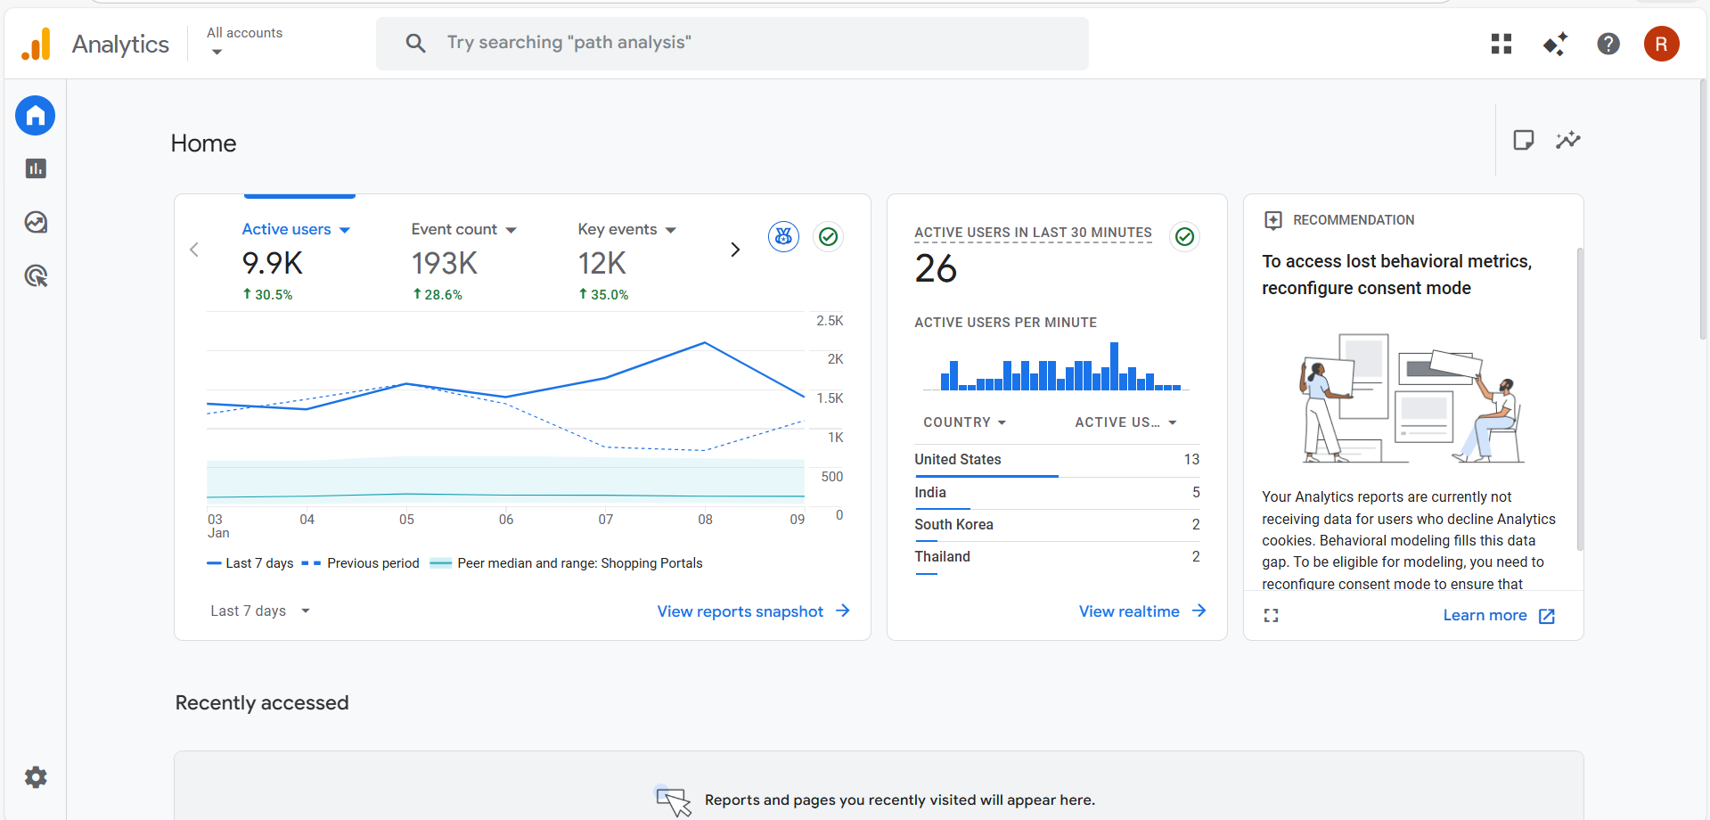
- Overview of Growth: I observed that the site is experiencing significant growth, with 9.9K active users, representing a 30.5% increase over the previous 7-day period.
- Key Activity Metrics: The total Event count reached 193K (up 28.6%), and Key events (conversions) totaled 12K, showing a strong 35% increase.
- Real-time Traffic: There were 26 active users on the site within the last 30 minutes, with a visible spike in activity occurring roughly 10–15 minutes prior.
- Top Geographic Markets: The United States leads with 13 active users, followed by India (5), South Korea (2), and Thailand (2).
- User Trends: The primary line chart shows that user activity peaked around January 8th.

Reports Snapshot
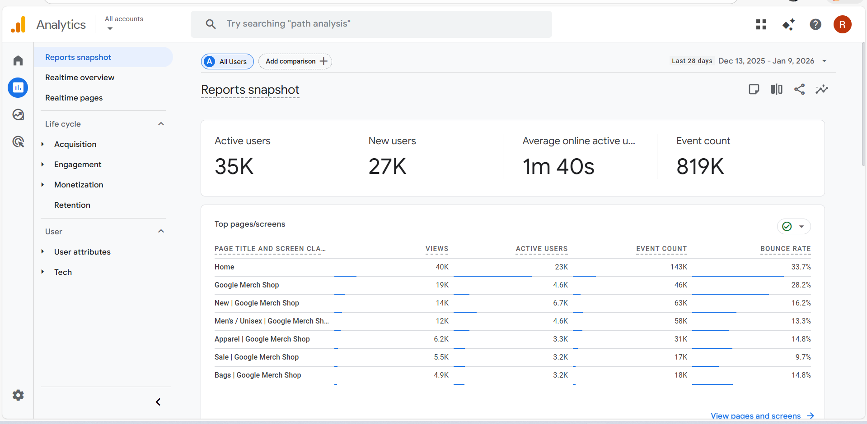
- Key Metrics: This page provides a high-level overview of the site’s performance, showing 35K active users and 27K new users over the last 28 days.
- Engagement: I observed an average engagement time of 1 minute and 40 seconds per user, with a total event count of 819K interactions.
- Top Pages: The "Home" page is the most visited, followed by the "Google Merch Shop" and "New" arrival sections.

Realtime Overview
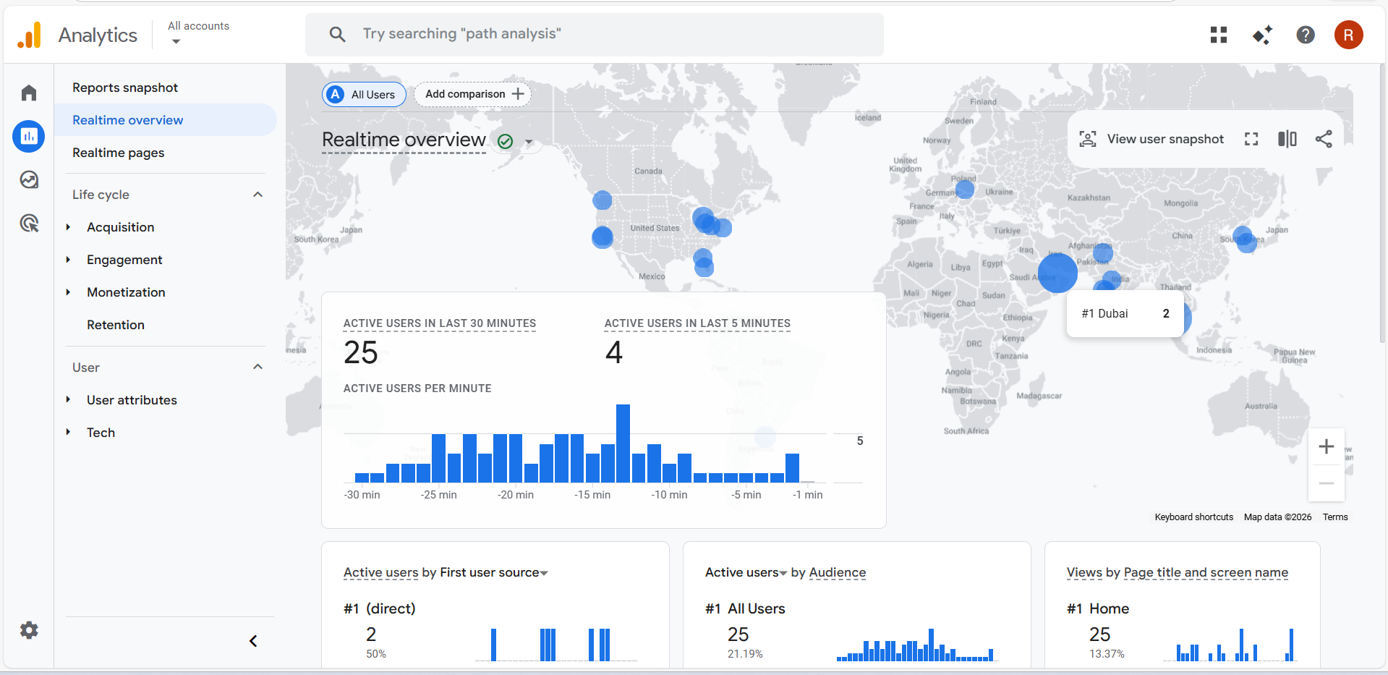
- Live Traffic: I observed a live map showing active users across the globe, with a specific cluster of 2 users currently active in Dubai.
- Engagement Flow: There were 25 active users in the last 30 minutes, primarily originating from "Direct" sources.
- Live Page Views: The "Home" page is currently the most viewed page by active users.

Realtime Pages
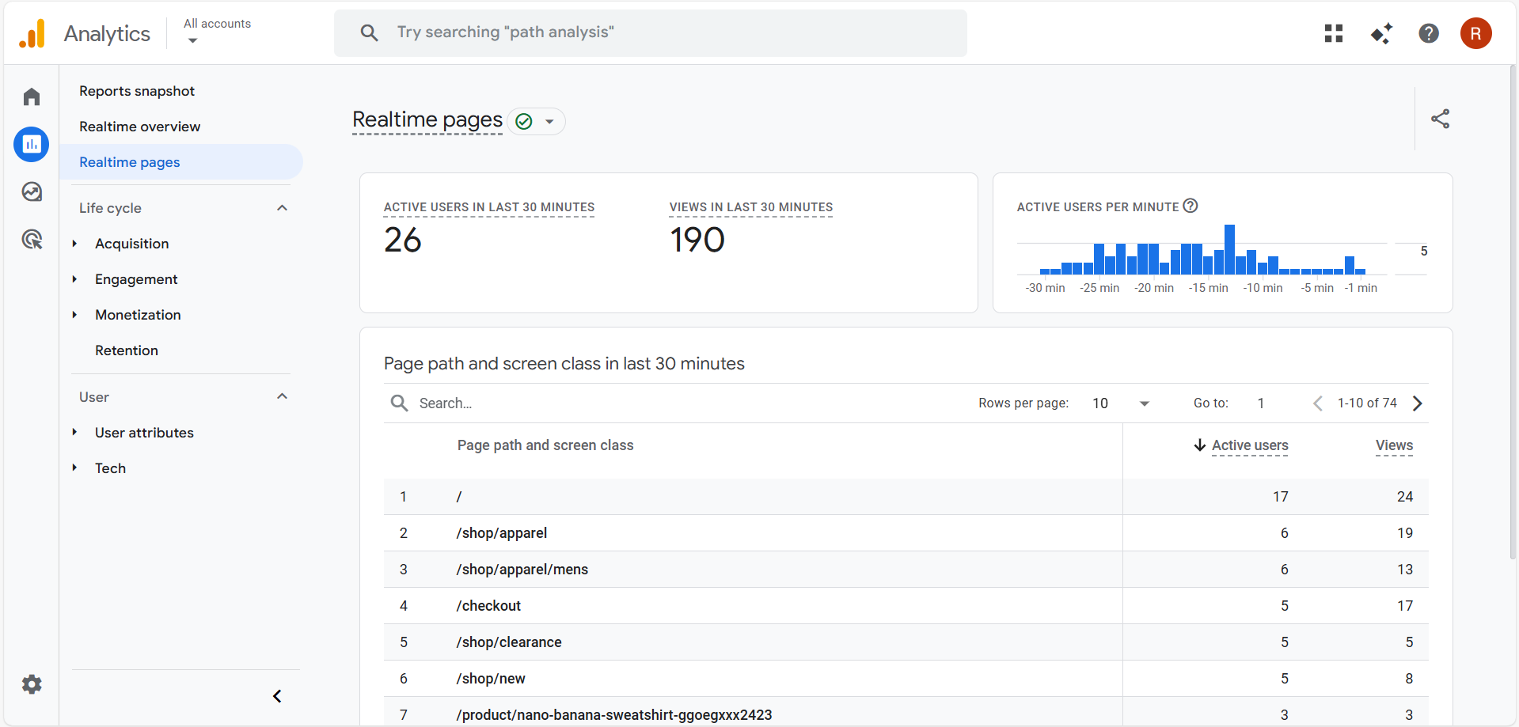
- Content Specifics: This report breaks down exactly which pages are being viewed right now, showing 190 total views in the last 30 minutes.
- Path Tracking: I noticed that after the Home page, the /shop/apparel and /checkout pages have the highest active user counts.
Acquisition Overview
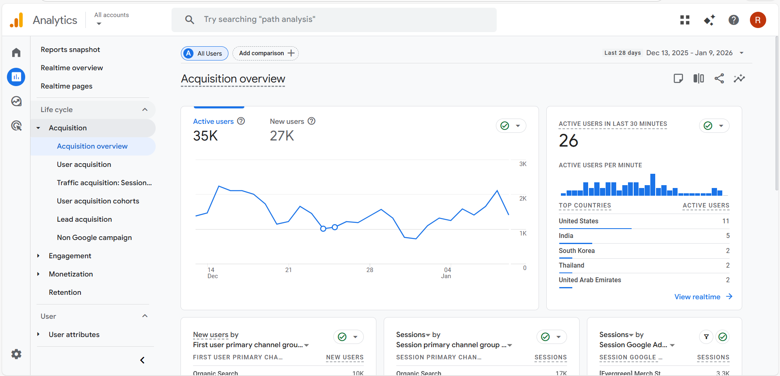
- User Trends: This page tracks how users find the site , I saw a peak in active users around early January.
- Country Data: In the last 30 minutes, the United States and India were the top two countries bringing in traffic.
Traffic Acquisition

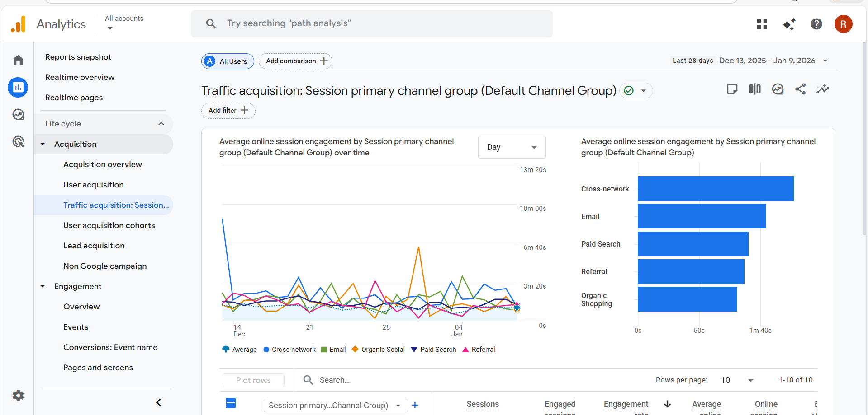

- Channel Performance: I analyzed the "Session primary channel group" and found that Organic Search and Direct traffic are the most consistent drivers of sessions over time.
- Engagement by Channel: The bar chart shows that "Cross-network" and "Email" channels actually have higher average session engagement times compared to organic search.

Engagement Overview

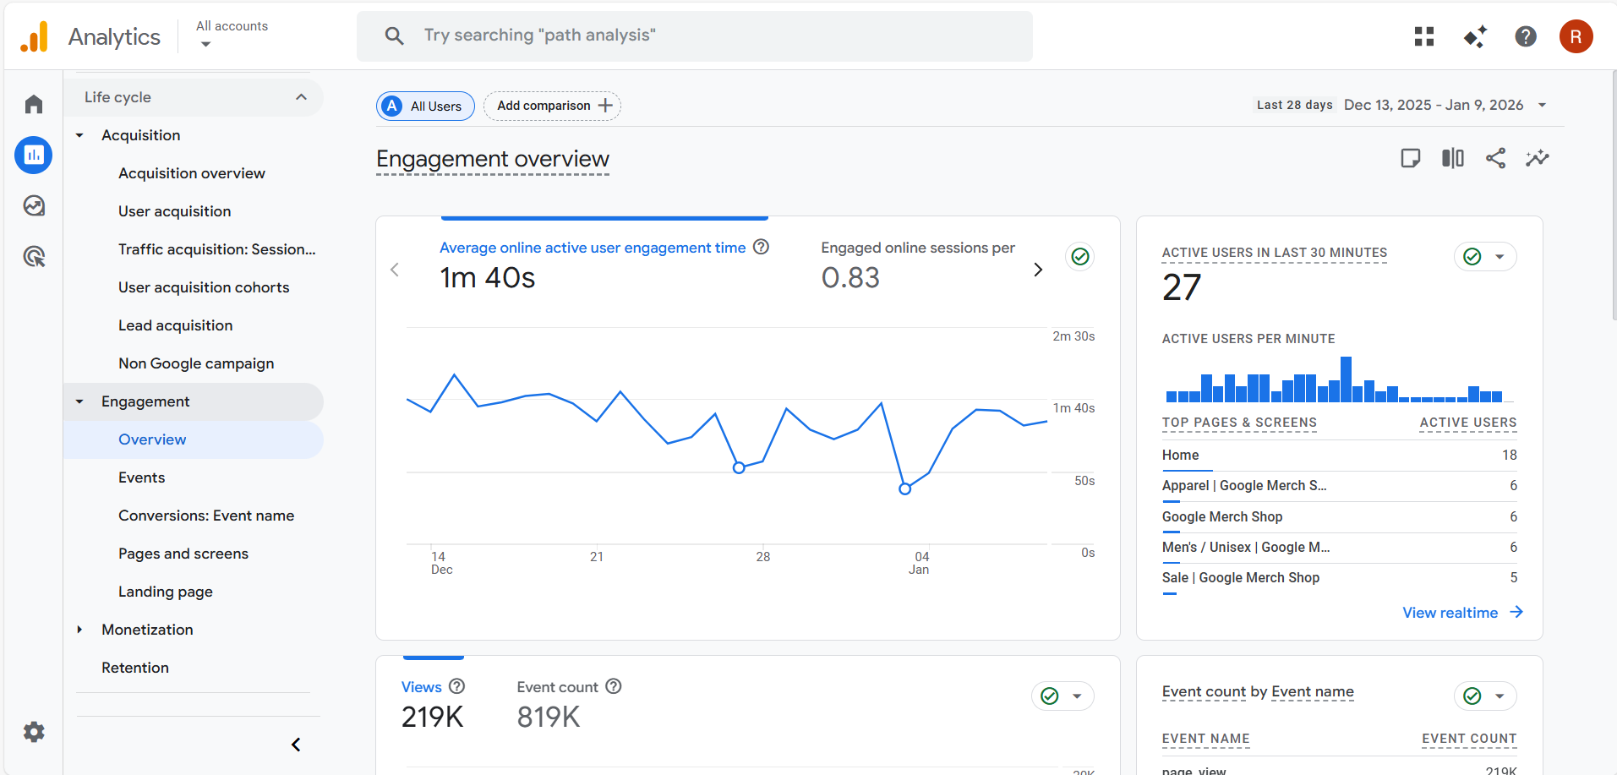

- Time on Site: This confirms the average engagement time is 1 minute and 40 seconds.
- Event Activity: I can see the total number of views 219K and the total event count 819K for the period, indicating that users perform multiple actions per visit.

Monetization Overview

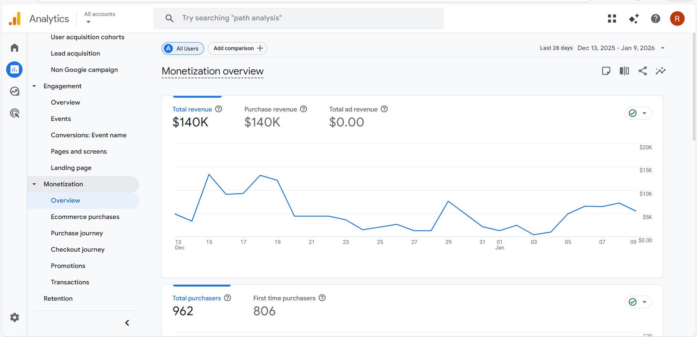

- Revenue: The site generated 140K in total revenue, all of which came from purchases rather than ads.
- Buyer Stats: I observed there were 962 total purchasers, with 806 of them being first-time buyers.

User Attributes Overview

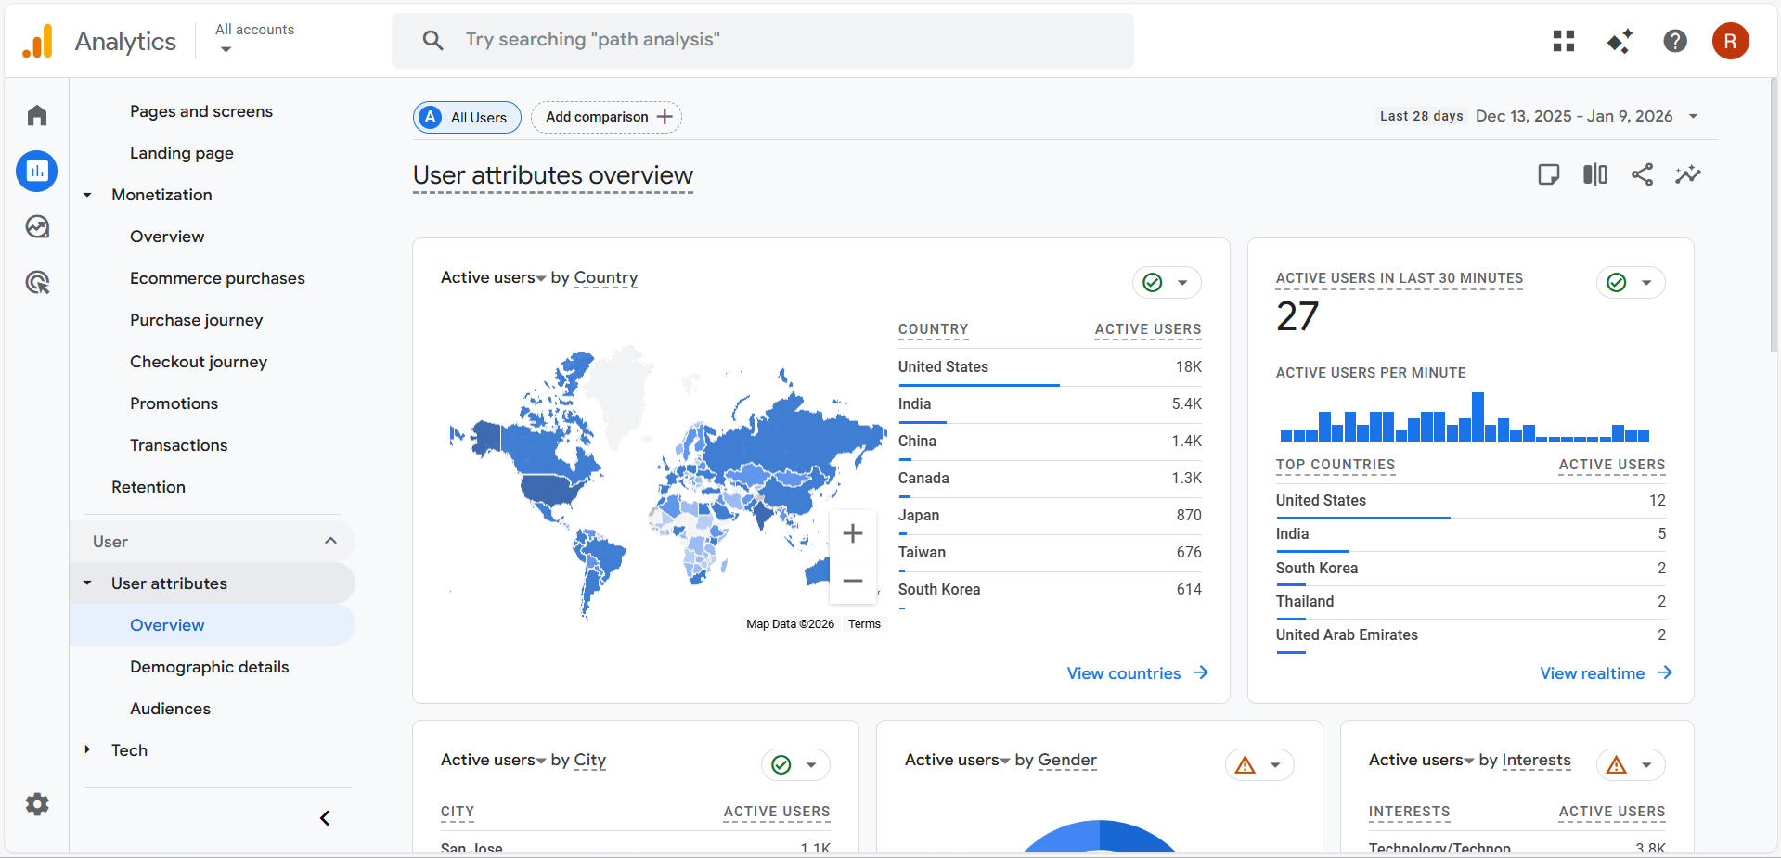

- Global Reach: The map shows a very heavy concentration of users in the United States 18K and India 5.4K.
- Demographics: I noticed that most users are concentrated in major cities like San Jose.

Tech Overview

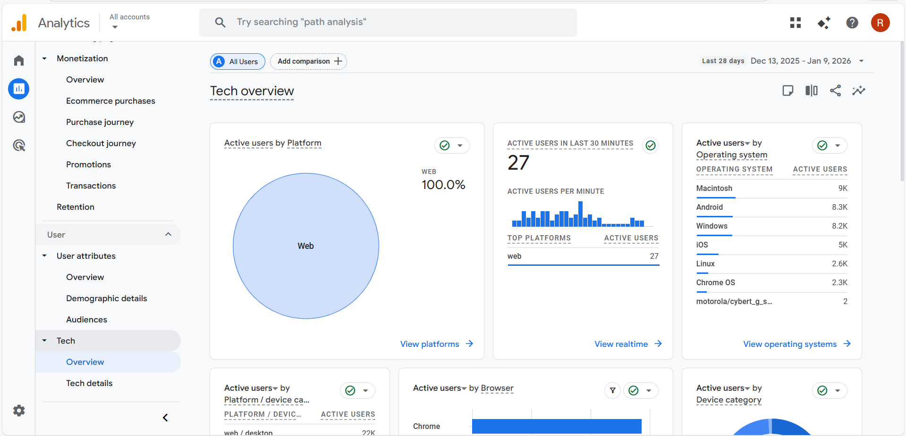
- Platform: 100% of the traffic for this specific property is coming from the Web platform.
- Operating Systems: Macintosh users are the largest group ($9\text{K}$), followed closely by Android 8.3K and Windows 8.2K.
- Browsers: Chrome is the dominant browser used by the majority of the audience.

Conclusion
This experiment provided a comprehensive understanding of the evolution of the web, from static Web 1.0 websites to interactive Web 2.0 platforms and intelligent Web 3.0 systems. The study of web analytics highlighted its role in systematically collecting, measuring, analyzing, and reporting website data to understand user behavior and evaluate website performance. In addition, the experiment involved a practical study of the Google Analytics demo website, which helped in observing real-time metrics such as traffic sources, user engagement, site behavior, and conversions. This practical exposure demonstrated the importance of web analytics tools in monitoring website performance, identifying areas for improvement, and supporting data-driven decisions to enhance overall website efficiency and user experience.

